2021

SUBHANKAR SASMAL

ADROIT CONSULTANCY

12/10/2021

INDUSTRIAL TRAINING REPORT

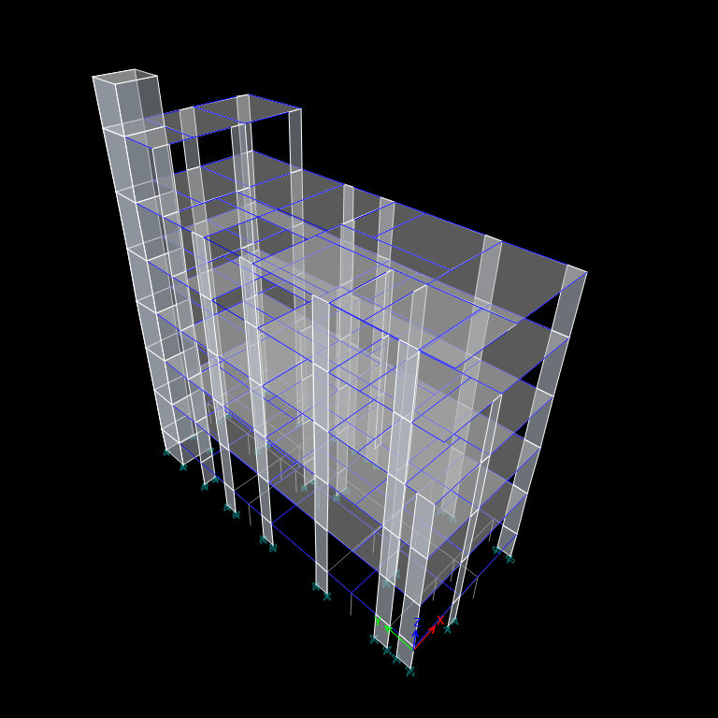

# STUDENT DETAILS

**NAME: SUBHANKAR SASMAL**

**ROLL NO.: 13001318033**

**YEAR: 4TH**

**SEMESTER: 7TH**

**COLLEGE: TECHNO MAIN SALT LAKE**

**DEPARTMENT: CIVIL ENGINEERING**

# ACKNOWLEDGEMENT

It is indeed a great honor and privilege to present this report on training at **Adroit Consultancy, Kolkata.**

I am extremely grateful to my Training and Placement Officer of my college

**Prof. Arghya Banerjee** for issuing the NOC, and **Kaberi Chattapadhyay** who issued my training letter that made my vocational training possible at **Adroit Consultancy, Kolkata.**

I would like to express my gratitude to **Mr. Mainak Majumdar (Partner, Adroit Consultant)** for his invaluable time, suggestions, motivations, guidance and support throughout the training. His methodology to start from the simple and then deepen through made me to bring out this project report thoroughly.

Thanks to all other Adroit Consultant officials, who rendered their assistance directly or indirectly to complete this project report successfully.

# INDEX

1. **INTRODUCTION 05**

***1.1*** *OBJECTIVES 06*

* 1. *METHODOLOGY 06*
  2. **LITERATURE REVIEW 07**
  3. *LOADS ON BUILDING 07*
  4. *CODE PROVISIONS 09*
  5. **SOFTWARES USED 10**
  6. *ETABS 2019 10*
  7. *AUTO CAD 2018 11*
  8. **PROJECT DESCRIPTION 11**
  9. *GENERAL 11*
  10. **STRUTURAL ANALYSIS 14**
  11. *GENERAL 14*
  12. *MEMBER PROPERTY SPECIFICATION 15*
  13. *STRUCTURAL MODELING IN ETABS 2019 16*
  14. *ARCHITECHTURAL DRAWING IN AUTOCAD 2018 19*
  15. *LOAD CALCULATIONS 20*

**6.0 ANALYSIS RESULT 23**

**7.0 STRUCTURE DATA 26**

**8.0 ANALYSIS REPORT 26**

***8.1*** *RESPONSE SPECTRUM FUNCTIONS 26*

***8.2*** *STRUCTURAL RESULTS 27*

**9.0 CONCLUSION 30**

**9.0 REFERENCES 31**

1. **INTRODUCTION**

The search of man for new methods for constructing his shelter and the invention of cement, led him to the use of multi-storey buildings in the form of framed structures. The R.C.C roofs made it easier to build on top of one another. More and more people began opting for multi-storey flats as the hand value increase in the population and limited land supply. showed a sharp increase, to exponential Due to scarcity of land and high these days. Recently, population density, multi-storied buildings are becoming a there have been a considerable increase in the number of tall buildings both residential and commercial and modern trend is towards taller and taller structures.

The advancement in science and technology had made it possible to build high rise structures in areas even susceptible to cyclones and earthquakes. Thus the effect of lateral loads like wind loads and earthquake forces are gaining importance and almost every designer is faced with problem of providing adequate strength and stability against lateral loads. These lateral forces can produce critical stresses in the structure, set up undesirable vibrations and in addition cause lateral sway of structure, which can reach a stage of discomfort to occupants.

In the design of a reinforced concrete structure, the aim is to provide a safe, serviceable, durable, economical and aesthetically pleasing structure. be safe, it must be able to resist the worst loading conditions. For the structure to Under normal working conditions, the deformation and cracking must not be excessive for the structure to remain serviceable, durable and aesthetically pleasing during the excepted design life. Furthermore, the structure should be economical with regard to both construction and maintenance cost.

As a part of the study, modelling, analysis, designing and detailing of a multi storied reinforced concrete building was done. In addition to this, visits to various construction sites were conducted. The site visits helped to be aware of the different construction methods that are adopted and being practiced in the construction industry.

**1.1 OBJECTIVES**

* To analysis a multistoried building using ETABS.
* To design the structural components
  + Beams
  + Columns
  + Slabs
  + Stair
  + Shear wall and
  + Foundation (pile)
  + To prepare detailing using Autocad.
  + Approach for professional practice in the field of structural engineering.

**1.2. METHODOLOGY**

The methodology followed for the design of G+4 building is:

* Preparation of Auto CAD drawings (plan, section and elevation).
* Calculation of loads.
* Analysis of the structure.
* Design and detailing of structural elements.

The obtained plan, section, and elevation of the building was drawn in Auto CAD 2016. 1987. Dead loads were obtained from the unit weight of material given in IS 875 (Part 1): Live loads were found from IS 875 (Part II): 1987. Preliminary dimensions of beams and slabs were found conforming to IS 456-2000. Load calculations for the one-way continuous slabs were done using Excel Sheets. Universal Excel sheets were prepared for the design of One-way continuous slab. Earthquake load was calculated using IS 1893(Part I): 1987. Analysis of the building is done using ETABS 2019 and moments, shear forces, and axial forces were obtained. Design of the structural elements beam, column, and foundation was done using the results obtained.

**2. LITERATURE REVIEW**

**2.1 LOADS ON BUILDING**

Loads acting on building are generated either by force or nature or are manmade. The natural forces are due to temperature, air, earthquake, gravitational force, etc. Manmade forces are generated by the movement of people, impact loads etc. The loads considered in the design include Dead Load, Live Load, Wind Load, Seismic Load etc.

**2.1.1 Dead Load**

All permanent Constructions of the structure form the Dead Loads. Dead Loads shall be calculated on the basis of unit weights which shall be established taking into account the materials specified for construction from IS 875 (Part I) 1987.

**2.1.2 Live Load**

The imposed loads to be assumed in the design of building shall be the greatest loads that probably will be produced by the intended use or occupancy, but shall not be less than the minimum loads specified in 1S 875 (Part 2) 1987. Floors shall be investigated for UDL and corresponding concentrated load. Imposed loads do not include loads due to wind, earthquake, snow etc.

**2.1.3 Wind Load**

Wind is air in motion relative to the surface of the earth. The primary cause of wind is traced to the earth's rotation, and the difference in terrestrial radiation. The radiation effects are primarily responsible for convection, either upwards or downwards. The wind generally blows horizontal to ground at high wind speeds. Since vertical components of atmospheric motion are relatively small, the term wind denotes almost exclusively the horizontal wind; vertical winds are always identified as such. The wind speeds are assessed with the aid of anemometers. or anemographs which are installed at meteorological observatories at heights generally varying from 10 to 30m above ground. Wind loads are calculated conforming to IS 875 part III 2015.

**2.1.4 Seismic Load**

The earth's crust is not static; it is subjected to constant motion. Since the foundation is a point of contact between building and earth, seismic motion acts on the building by shaking the foundation back and forth.

The severity of earthquakes in different parts of India is different. The seismicity at a place is assessed by its distance from the active fault in the rock formation. In general, the seismic zoning of a country depends on the seismic history of different regions. As per IS 1893 (Part 1): 2016, India has been divided into four zones, designated as Zone II, III, IV, and V. Raiganj is in zone IV.

**2.2 CODE PROVISIONS**

* IS 456:2000

Limit state method of design

* IS 875 (Part I): 1987

Unit Weight of Building Materials.

* IS 875 (Part II): 1987

This standard covers imposed load to be assumed in design of buildings.

* IS 875 (Part III): 1987

This standard gives wind forces and their effects.

* Is 1893 (Part I)

This standard deals with the assessment of seismic loads on various structures and earthquake resistant design of buildings.

**3. SOFTWARES USED**

The study allowed me to acquaint myself with a number of software. The most frequently used software include:

1. ETABS 2019
2. Auto CAD 2018

**3.1 ETABS 2019**

The innovative and revolutionary new ETABS is the ultimate integrated software package for the structural analysis and design of buildings Incorporating 40 years of continuous research and development, this latest ETABS offers unmatched 3D object based modeling and visualization tools, blazingly fast linear and nonlinear analytical power, sophisticated and comprehensive design capabilities for a wide range of materials, and insightful graphic displays, reports, and schematic drawings that allow users to quickly and easily understand analysis and design results. Advantages of ETABS are:

* Graphic input and editing for easy and fast model generation
* 3D generation of the model through plan views and elevations. Fast model generation using the concept of similar stories Easy editing through the Move, Merge, Mirror and Copy commands
* Accuracy in dimensions by using Snaps (end, perpendicular, middle etc.)
* Fast object creation with one click of the mouse
* Multiple viewing windows
* 3D view with zoom and pan capability
* 3D axonometric view of the model, plan view, elevation view, elevation development view, custom view defined by the user

**3.2 AUTO CAD 2018**

Auto CAD is a CAD (Computer-Aided Design or Computer Aided Drafting) software application for 2D and 3D design and drafting developed and sold by Autodesk. Inc. It is a vector graphics drawing programmed. It uses primitive entities such as lines. poly-lines, circles, arcs and text-as the foundation for the complex objects. Auto CAD's native file format, DWG, and to a lesser extent, its interchange file format, DXF has become the standard for the interchange of CAD data. All the drawing and detailing works were done by making use of Auto CAD 2018.

**4. PROJECT DESCRIPTION**

**4.1 GENERAL**

The study consists of two parts. The first part was devoted to the modeling and analysis of an SMRF Building and the second part consists of designing and detailing of the structure. The proposed site is at Raiganj. The building is planned to serve the purpose of a residential and commercial suit. It consists of Ground + 4 storey of SMRF Buiding. The floor plans are given below.

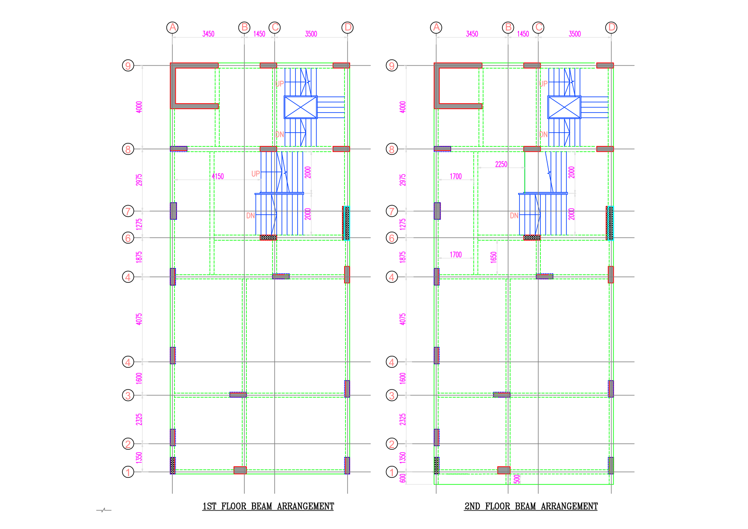

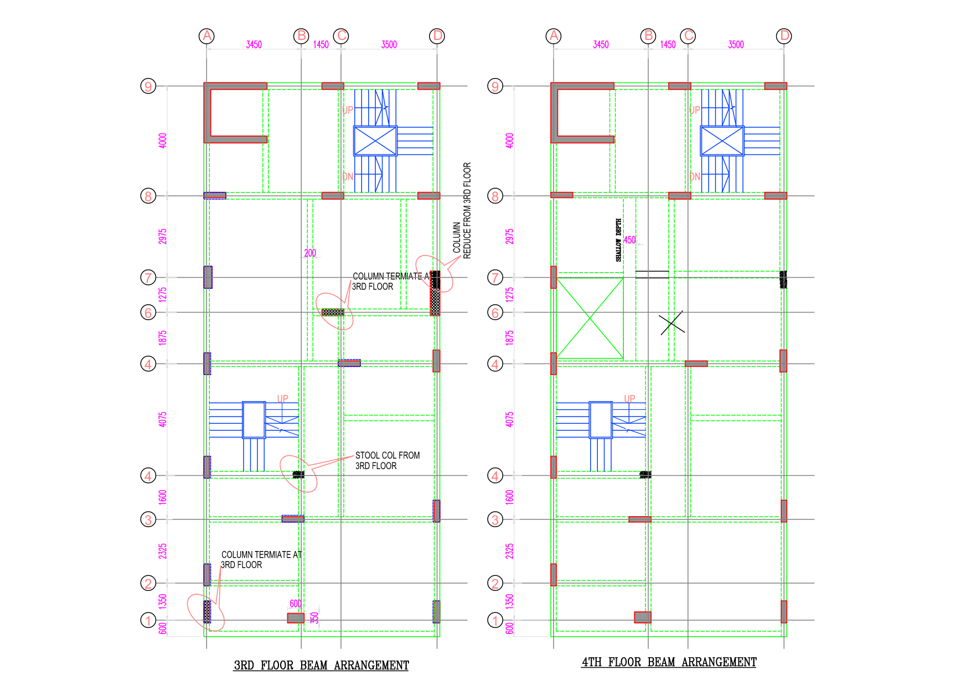

The beam and column layouts are first fixed and the modelling will be done using software ETABS 2019. During analysis, the dead loads and live loads will be calculated from IS: 875(Part 1 and 2) and seismic load calculated by referring

IS 1893 (Part 1) 2002 and wind loads calculated from IS:875 (Part 3) - 1987 and their combinations were applied on the space frame. An equilibrium check on the support reaction was made to ensure the correctness of the analysis. From the analysis, various load combinations were taken to obtain the maximum design loads, moments and shear on each member. The design is carries as per IS code for the critical load combinations. The concrete mix used is M25 for beams, slabs, columns and piles etc. and the steel used is Fe 500 grade.

**5. STRUCTURAL ANALYSIS**

**5.1 GENERAL**

Structural analysis is an integral part of any engineering project, it is the process of predicting the performance of the given structure under prescribed loading conditions. Thus, analysis of a structure typically involves the determination of those quantities caused by the given loads and other external effects. In the design of reinforced concrete structures, the aim is to provide a safe, durable, economical and aesthetically pleasing structure. Analysis of structure typically involves the determination of structural loads, geometry, support conditions, and material properties. The results of such an analysis include support reactions, stresses and displacements. The aim of the design is the achievement of an acceptable probability that structures being designed will perform satisfactorily during their intended life. With an appropriate degree of safety, they should sustain all the loads and deformations of normal construction and use and have adequate durability and adequate resistance to the effects of seismic and wind.

Structure and structural elements hall normally be designed by Limit State Method. The design of the building is dependent upon the minimum requirements as prescribed in the Indian Standard Codes. The minimum requirements pertaining to the structural safety of buildings are being covered by way of laying down minimum design loads which have to be assumed for dead loads, imposed loads, and other external loads, the structure would be required to bear.

**5.2 MEMBER PROPERTY SPECIFICATION**

Table 5.1 : Properties of the member sections

|  |  |  |
| --- | --- | --- |
| MEMBER | | DIMENSIONS (mm) |
| SLAB | S1 | 125 |
| S2 | 150 |
| COLUMN | C1 | 250 x 800 |
| C2 | 300 x 800 |
| C3 | 350 x 600 |
| C4 | 250 x 625 |
| C5 | 350 x 1625 |
| BEAM | B1 | 250 x 500 |
| B2 | 200 x 500 |
| B3 | 450 x 350 |

**5.3 STRUCTURAL MODELLING IN ETABS 2019**

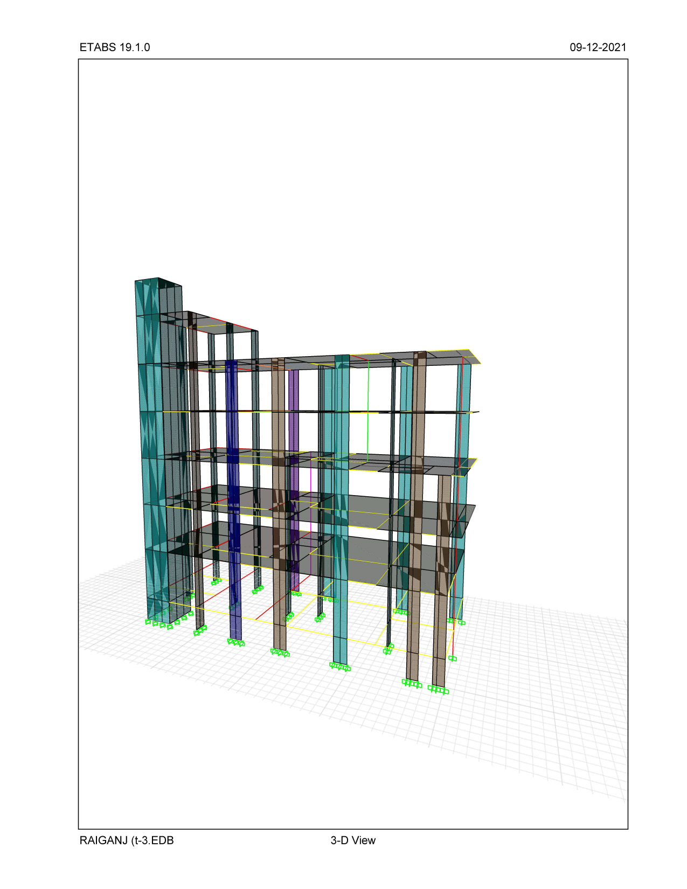

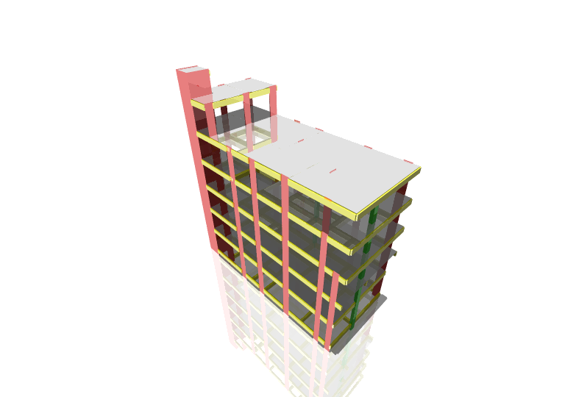

Fig. Rendered view of the model

**5.4 ARCHITECTURAL MODEL IN AUTOCAD 2018**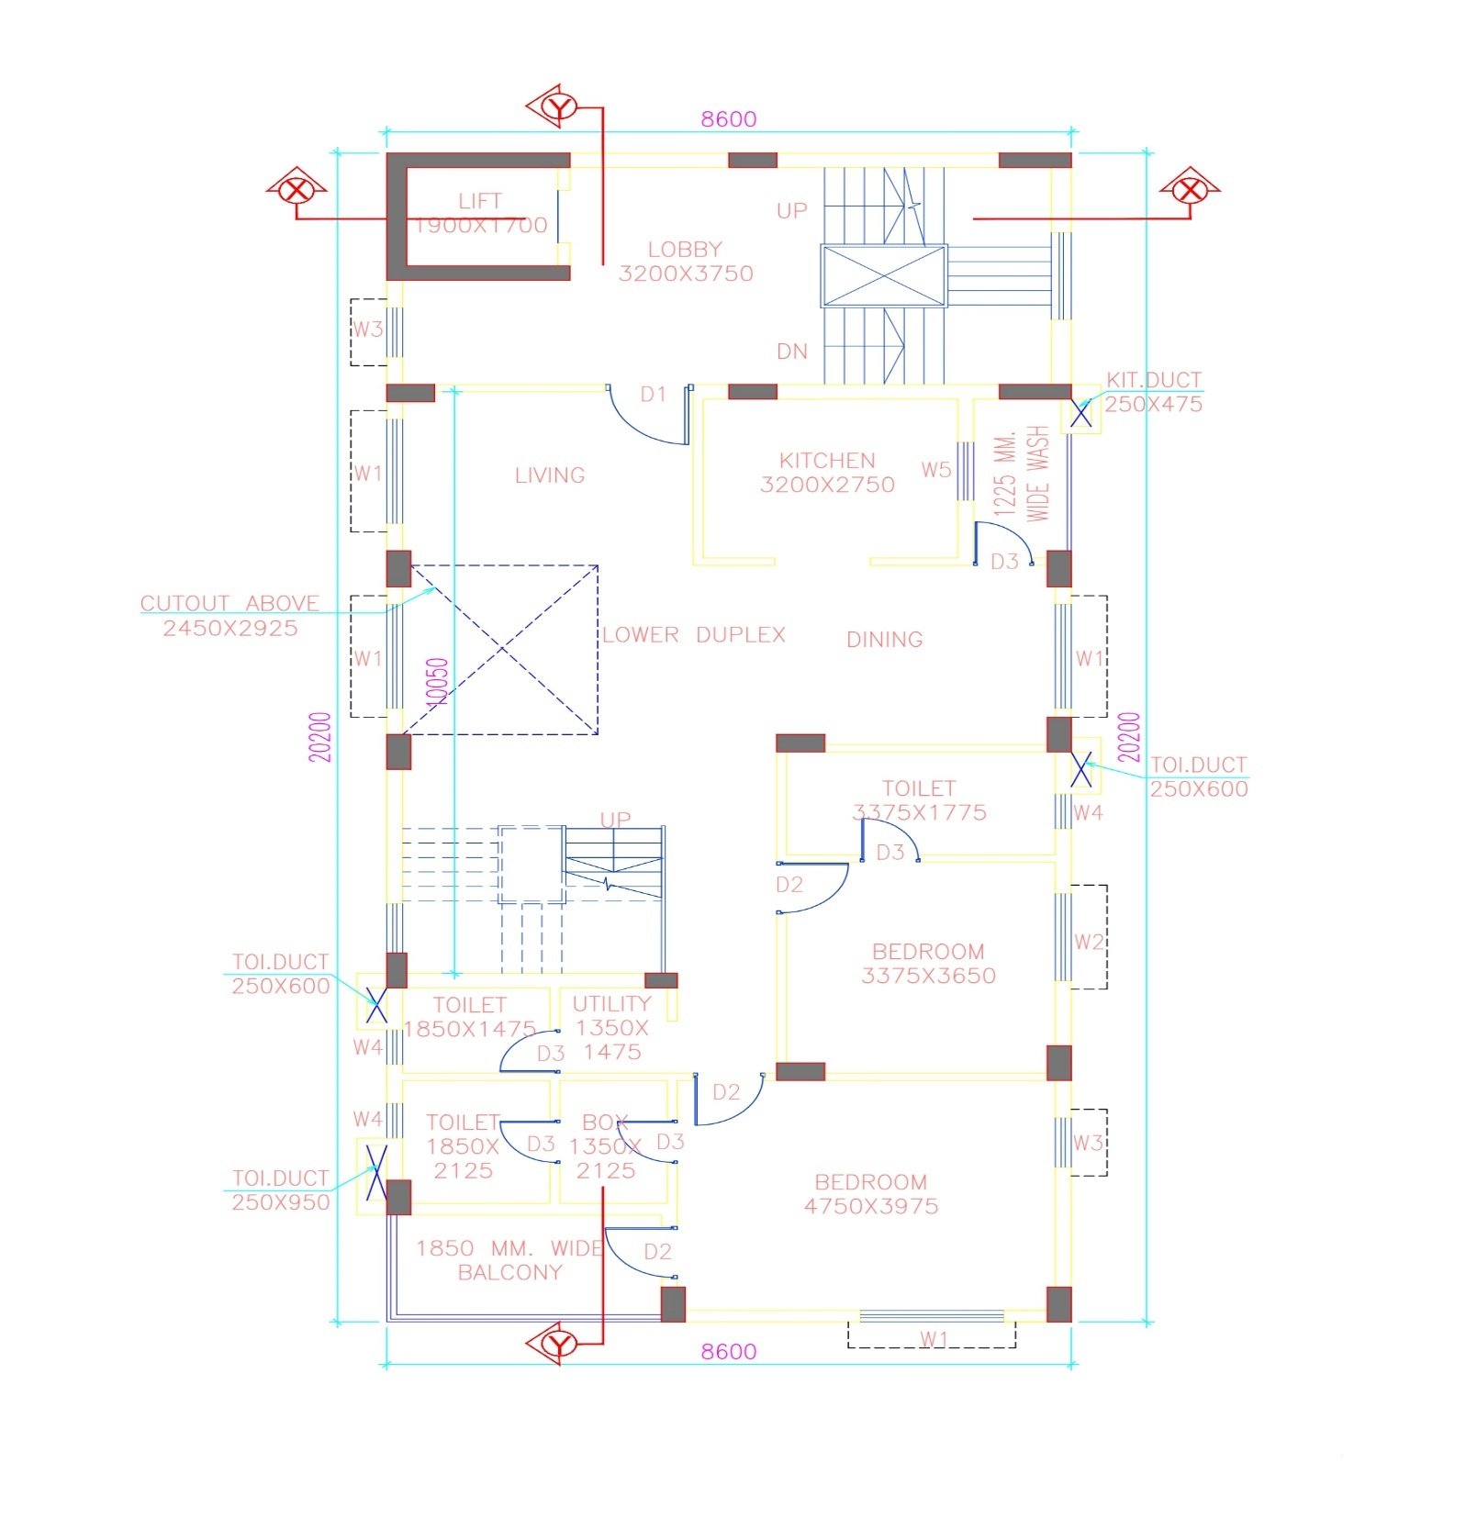

**5.5 LOAD CALCULATIONS**

The different load cases which are considered are dead load, live load and seismic load.

**5.5.1 DEAD LOAD CALCULATIONS**

Dead load is primarily due to the self-weight of structural members, permanent partition walls, fixed permanent equipment, and weights of different materials. Loads shall be calculated on the basis of unit weight of materials used and is specified in

IS 875 (Part I) 1987.

Self weight of wall due to brick = Unit weight of brick x Thickness of wall x (Height of wall - Depth of Beam)

Self-weight of the structural members will be considered on the basis of the following properties :

|  |  |  |  |
| --- | --- | --- | --- |
| 1. | Density of reinforced concrete | 2.50 | T/m3 |
| 2. | Density of plain concrete | 2.40 | T/m3 |
| 3. | Density of steel | 7.85 | T/m3 |
| 4. | Density of floor plasters | 2.10 | T/m3 |
| 5. | Density of floor finishes | 2.40 | T/m3 |
| 6. | Density of soil | 1.80 | T/m3 |
| 7. | Density of AAC Block | 1.00 | T/m3 |
| 8. | Density of Solid concrete Block | 2.30 | T/m3 |

**5.5.2 Live Load Calculations**

Live loads were taken from IS 875: 1987 (Part 2). Table 5.2 shows the uniformly distributed loads in rooms.

**Table 5.2 : Live load in rooms**

|  |  |  |
| --- | --- | --- |
| Sl. no | Components of building | T/m^2 |
| 1 | Bedrooms | 0.2 |
| 2 | Toilets and Bathrooms | 0.2 |
| 3 | Corridors, Passages, Lobbies, Staircases including fire escapes | 0.3 |
| 4 | Balcony | 0.3 |
| 5 | Retail Shops | 0.4 |
| 6 | Mercantile Building Staircases | 0.4 |

**5.4.3 Earthquake Forces**

Earthquakes generate beams which moves from the origin of its location with velocities depending on the intensity and magnitude on earthquake. The impact of earthquake on structures depends on the stiffness of the structure, stiffness of the soil media, height and location of the structure etc. The earthquake forces are prescribed in IS 1893: 2002 Part 1. Since the building is located in Raiganj, it is included in IV, and seismic base shear calculation and its distribution was done as per IS 1893: 2016 Part 1 Clause 7.5.3.

The base shear or total design lateral force along any principal direction shall be determined by the following expressions:

Vb = Ah x W

Where,

Vb = Design seismic base shear

Ah = Design horizontal acceleration spectrum value using the fundamental natural period in the considered direction of vibration.

W = Seismic Weight of the building

The design horizontal seismic coefficient as per Clause 6.4.2 of IS 1893: 2016 Part 1

Ah = (Z I S a) / (2 R g)

Where,

Z = Zone factor

Zone factor for different seismic zones is given below in table 5.3

Table 5.3 : Zone Factor

|  |  |  |  |  |
| --- | --- | --- | --- | --- |
| Seismic Zone | II | III | IV | V |
| Seismic  Intensity | Low | Moderate | Severe | Very Severe |
| Zone Factor | 0.10 | 0.16 | 0.24 | 0.36 |

I = Importance Factor (Table 6 of IS 1893 (Part 1): 2016)

R = Response reduction factor (Table 7 of IS 1893 (Part 1): 2016)

s/g = Average response acceleration coefficient

The seismic analysis of the proposed building was done by using the software ETABS 2019 as per IS 1893 (Part 1): 2016 by giving the following data

Zone factor, Z = 0.24

Importance Factor, I = 1.2

Response reduction factor, R = 5

**6. ANALYSIS RESULT**

Analysis results can be obtained in the graphical as well as in tabular form, from which the maximum bending moment values are obtained for each member. Concrete dimension and reinforcement quantities are designed from these quantities appropriately. The bending moment diagram is shown in the figures below.

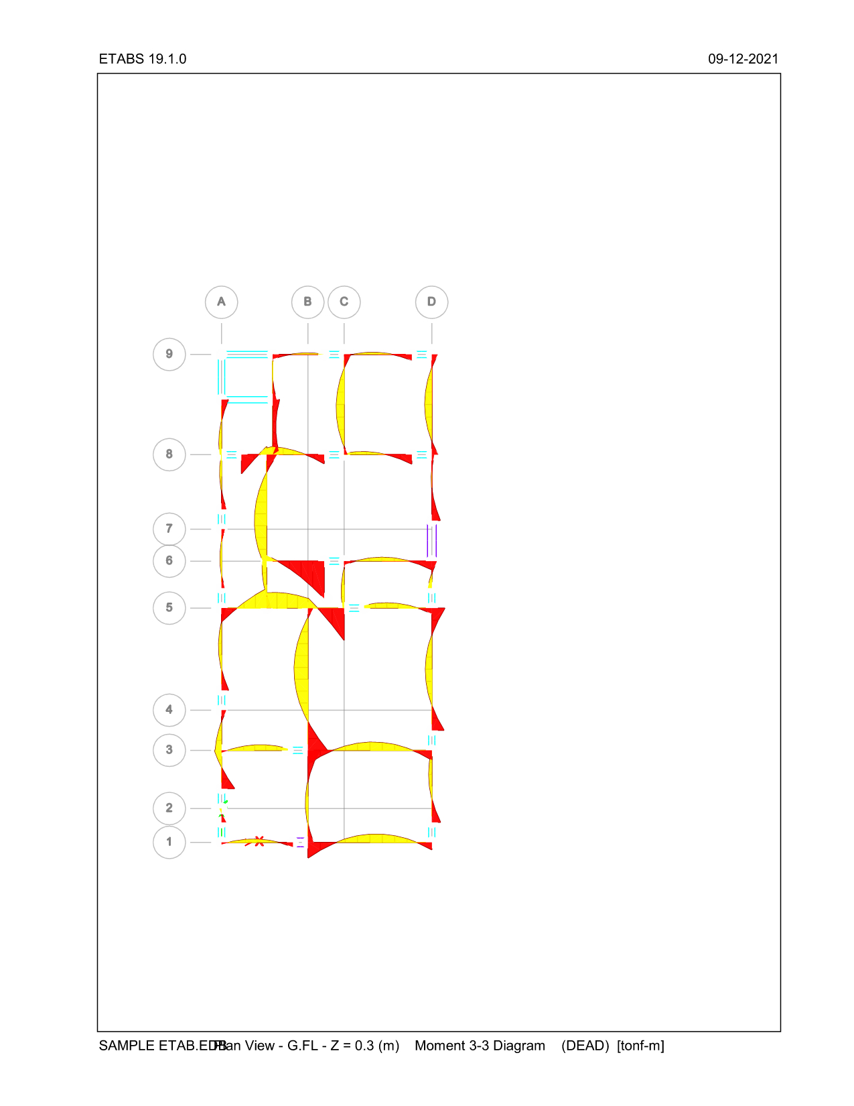

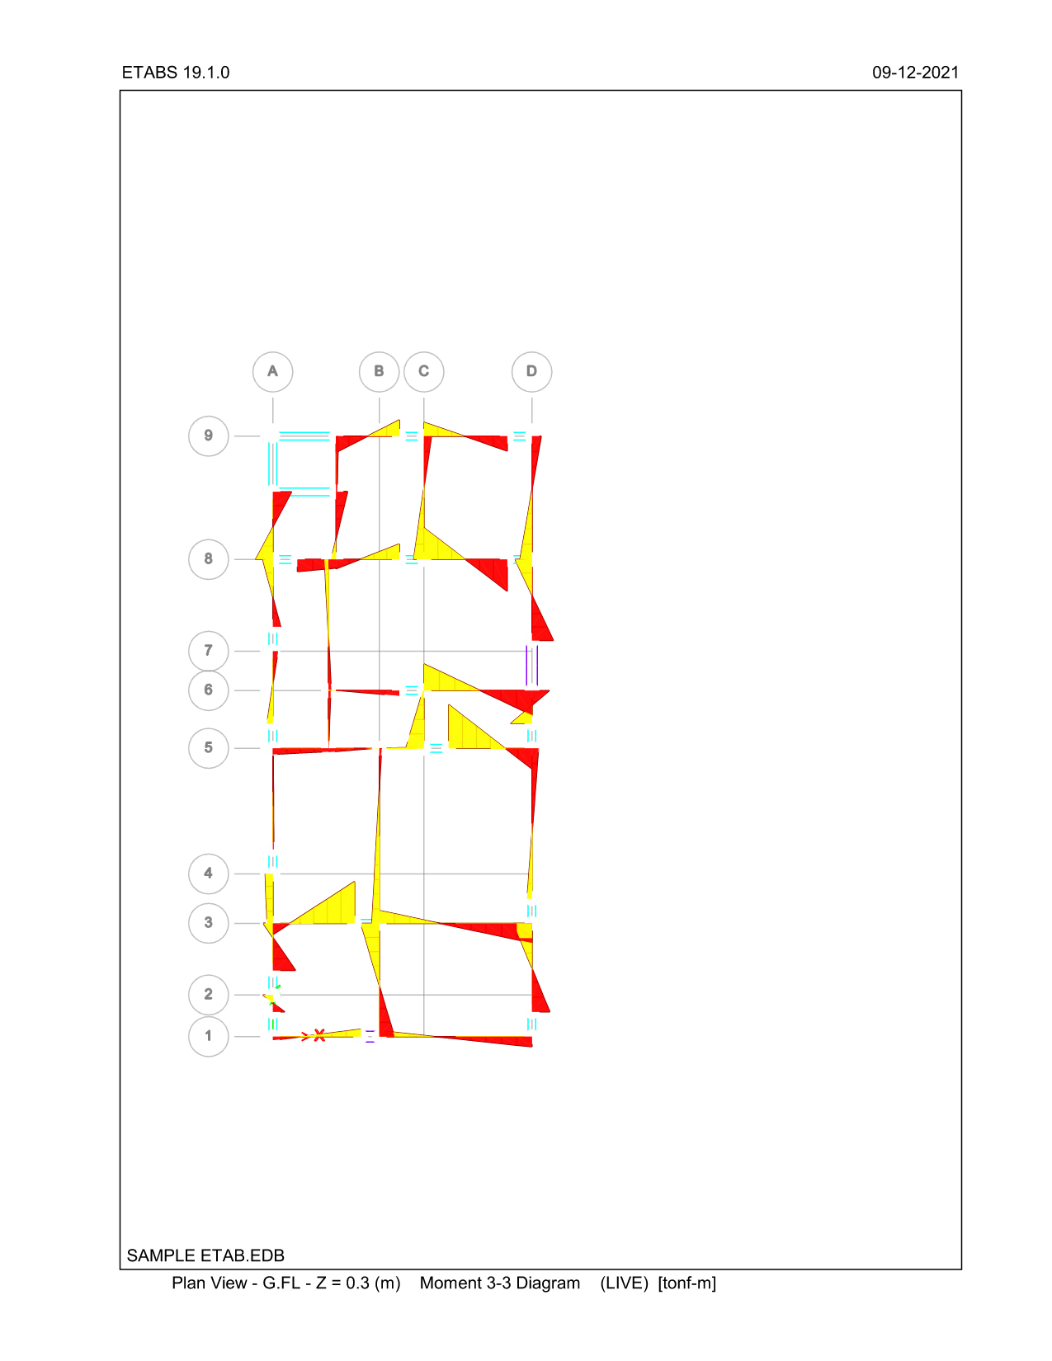

**7. STRUCTURE DATA**

Table - Story Definitions

| Tower | Name | Height  m | Master Story | Similar To | Splice Story | Color |
| --- | --- | --- | --- | --- | --- | --- |
| T1 | LIFT HEADROOM | 2.15 | Yes | None | No | Red |
| T1 | STR HEADROOM | 3 | Yes | None | No | Red |
| T1 | ROOF | 3 | Yes | None | No | Red |
| T1 | 4TH FLOOR | 3.025 | Yes | None | No | Red |
| T1 | 3RD FLOOR | 3.05 | Yes | None | No | Red |
| T1 | 2ND FLOOR | 3.05 | No | 3RD FLOOR | No | Magenta |
| T1 | 1ST FLOOR | 3.05 | No | 3RD FLOOR | No | Yellow |
| T1 | G.FL | 1.8 | No | 3RD FLOOR | No | White |

**8. ANALYSIS REPORT**

**8.1 RESPONSE SPECTRUM FUNCTIONS**

Table - Functions - Response Spectrum - IS1893 2016

| Name | Period  sec | Value | Seismic Zone | I | Soil Type | R | Damping Ratio |
| --- | --- | --- | --- | --- | --- | --- | --- |
| IS 1893-2016 | 0 | 0.0288 | IV | 1.2 | II | 5 | 0.05 |
| IS 1893-2016 | 0.1 | 0.072 |  |  |  |  |  |
| IS 1893-2016 | 0.55 | 0.072 |  |  |  |  |  |
| IS 1893-2016 | 0.8 | 0.04896 |  |  |  |  |  |
| IS 1893-2016 | 1 | 0.039168 |  |  |  |  |  |
| IS 1893-2016 | 1.2 | 0.03264 |  |  |  |  |  |
| IS 1893-2016 | 1.4 | 0.027977 |  |  |  |  |  |
| IS 1893-2016 | 1.6 | 0.02448 |  |  |  |  |  |
| IS 1893-2016 | 1.8 | 0.02176 |  |  |  |  |  |
| IS 1893-2016 | 2 | 0.019584 |  |  |  |  |  |
| IS 1893-2016 | 2.5 | 0.015667 |  |  |  |  |  |
| IS 1893-2016 | 3 | 0.013056 |  |  |  |  |  |
| IS 1893-2016 | 3.5 | 0.011191 |  |  |  |  |  |
| IS 1893-2016 | 4 | 0.009792 |  |  |  |  |  |
| IS 1893-2016 | 4.5 | 0.009792 |  |  |  |  |  |
| IS 1893-2016 | 5 | 0.009792 |  |  |  |  |  |
| IS 1893-2016 | 5.5 | 0.009792 |  |  |  |  |  |
| IS 1893-2016 | 6 | 0.009792 |  |  |  |  |  |
| IS 1893-2016 | 6.5 | 0.009792 |  |  |  |  |  |
| IS 1893-2016 | 7 | 0.009792 |  |  |  |  |  |
| IS 1893-2016 | 7.5 | 0.009792 |  |  |  |  |  |
| IS 1893-2016 | 8 | 0.009792 |  |  |  |  |  |
| IS 1893-2016 | 8.5 | 0.009792 |  |  |  |  |  |
| IS 1893-2016 | 9 | 0.009792 |  |  |  |  |  |
| IS 1893-2016 | 9.5 | 0.009792 |  |  |  |  |  |
| IS 1893-2016 | 10 | 0.009792 |  |  |  |  |  |

**8.2 STRUCTURAL RESULTS**

Table - Base Reactions (Part 1 of 2)

| Output Case | Case Type | Step Type | FX  tonf | FY  tonf | FZ  tonf | MX  tonf-m | MY  tonf-m | MZ  tonf-m |
| --- | --- | --- | --- | --- | --- | --- | --- | --- |
| DEAD | LinStatic |  | 0 | 0 | 694.7371 | 7647.6305 | -2689.9504 | 0 |
| LIVE | LinStatic |  | 0 | 0 | 244.3335 | 2528.5412 | -1010.5225 | 0 |
| SDL | LinStatic |  | 0 | 0 | 159.7916 | 1775.5744 | -702.251 | 0 |
| AAC BWK | LinStatic |  | 0 | 0 | 555.1812 | 5810.0997 | -2350.219 | 0 |
| FILLING | LinStatic |  | 0 | 0 | 0 | 0 | 0 | 0 |
| PROJECTION LOAD | LinStatic |  | 0 | 0 | 0 | 0 | 0 | 0 |
| SLX | LinStatic |  | -92.6426 | 0 | 0 | 0 | -1372.9039 | 1070.0524 |
| SLY | LinStatic |  | 0 | -92.6426 | 0 | 1372.9039 | 0 | -370.3711 |
| WLX | LinStatic | Max | 40.5603 | 0 | 0 | 0 | 410.9639 | 394.9561 |
| WLX | LinStatic | Min | -40.5603 | 0 | 0 | 0 | -410.9639 | -394.9561 |
| WLY | LinStatic | Max | 0 | 14.3137 | 0 | 145.0291 | 0 | 60.1177 |
| WLY | LinStatic | Min | 0 | -14.3137 | 0 | -145.0291 | 0 | -60.1177 |
| SPECX | LinRespSpec | Max | 53.6427 | 25.375 | 0 | 327.6117 | 674.3469 | 527.4506 |
| SPECY | LinRespSpec | Max | 25.375 | 69.4496 | 0 | 910.4079 | 336.3386 | 618.8009 |
| CLAY BWK EXCESS | LinStatic |  | 0 | 0 | 0 | 0 | 0 | 0 |
| DL TOTAL | Combination |  | 0 | 0 | 1409.7099 | 15233.3046 | -5742.4205 | 0 |
| DL+0.5LL | Combination |  | 0 | 0 | 1531.8767 | 16497.5752 | -6247.6817 | 0 |
| 1.2DL+1.2LL+1.2SLX | Combination |  | -111.1712 | 0 | 1984.8522 | 21314.2149 | -9751.0163 | 1284.0629 |
| 1.2DL+1.2LL-1.2SLX | Combination |  | 111.1712 | 0 | 1984.8522 | 21314.2149 | -6456.047 | -1284.0629 |
| 1.2DL+1.2LL+1.2SLY | Combination |  | 0 | -111.1712 | 1984.8522 | 22961.6996 | -8103.5316 | -444.4453 |
| 1.2DL+1.2LL-1.2SLY | Combination |  | 0 | 111.1712 | 1984.8522 | 19666.7302 | -8103.5316 | 444.4453 |
| 1.2DL+1.2LL+1.2WLX | Combination | Max | 48.6724 | 0 | 1984.8522 | 21314.2149 | -7610.375 | 473.9473 |
| 1.2DL+1.2LL+1.2WLX | Combination | Min | -48.6724 | 0 | 1984.8522 | 21314.2149 | -8596.6882 | -473.9473 |
| 1.2DL+1.2LL-1.2WLX | Combination | Max | 48.6724 | 0 | 1984.8522 | 21314.2149 | -7610.375 | 473.9473 |
| 1.2DL+1.2LL-1.2WLX | Combination | Min | -48.6724 | 0 | 1984.8522 | 21314.2149 | -8596.6882 | -473.9473 |
| 1.2DL+1.2LL+1.2WLY | Combination | Max | 0 | 17.1765 | 1984.8522 | 21488.2499 | -8103.5316 | 72.1412 |
| 1.2DL+1.2LL+1.2WLY | Combination | Min | 0 | -17.1765 | 1984.8522 | 21140.1799 | -8103.5316 | -72.1412 |
| 1.2DL+1.2LL-1.2WLY | Combination | Max | 0 | 17.1765 | 1984.8522 | 21488.2499 | -8103.5316 | 72.1412 |
| 1.2DL+1.2LL-1.2WLY | Combination | Min | 0 | -17.1765 | 1984.8522 | 21140.1799 | -8103.5316 | -72.1412 |
| 1.2DL+1.2LL+1.2SPECX | Combination | Max | 64.3712 | 30.45 | 1984.8522 | 21707.3489 | -7294.3153 | 632.9407 |
| 1.2DL+1.2LL+1.2SPECX | Combination | Min | -64.3712 | -30.45 | 1984.8522 | 20921.0809 | -8912.7479 | -632.9407 |
| 1.2DL+1.2LL-1.2SPECX | Combination | Max | 64.3712 | 30.45 | 1984.8522 | 21707.3489 | -7294.3153 | 632.9407 |
| 1.2DL+1.2LL-1.2SPECX | Combination | Min | -64.3712 | -30.45 | 1984.8522 | 20921.0809 | -8912.7479 | -632.9407 |
| 1.2DL+1.2LL+1.2SPECY | Combination | Max | 30.45 | 83.3396 | 1984.8522 | 22406.7043 | -7699.9253 | 742.5611 |
| 1.2DL+1.2LL+1.2SPECY | Combination | Min | -30.45 | -83.3396 | 1984.8522 | 20221.7255 | -8507.1379 | -742.5611 |
| 1.2DL+1.2LL-1.2SPECY | Combination | Max | 30.45 | 83.3396 | 1984.8522 | 22406.7043 | -7699.9253 | 742.5611 |
| 1.2DL+1.2LL-1.2SPECY | Combination | Min | -30.45 | -83.3396 | 1984.8522 | 20221.7255 | -8507.1379 | -742.5611 |
| 1.5DL+1.5SLX | Combination |  | -138.964 | 0 | 2114.5649 | 22849.9569 | -10672.9865 | 1605.0787 |
| 1.5DL-1.5SLX | Combination |  | 138.964 | 0 | 2114.5649 | 22849.9569 | -6554.2749 | -1605.0787 |
| 1.5DL+1.5SLY | Combination |  | 0 | -138.964 | 2114.5649 | 24909.3127 | -8613.6307 | -555.5566 |
| 1.5DL-1.5SLY | Combination |  | 0 | 138.964 | 2114.5649 | 20790.601 | -8613.6307 | 555.5566 |
| 1.5DL+1.5WLX | Combination | Max | 60.8405 | 0 | 2114.5649 | 22849.9569 | -7997.1849 | 592.4342 |
| 1.5DL+1.5WLX | Combination | Min | -60.8405 | 0 | 2114.5649 | 22849.9569 | -9230.0765 | -592.4342 |
| 1.5DL-1.5WLX | Combination | Max | 60.8405 | 0 | 2114.5649 | 22849.9569 | -7997.1849 | 592.4342 |
| 1.5DL-1.5WLX | Combination | Min | -60.8405 | 0 | 2114.5649 | 22849.9569 | -9230.0765 | -592.4342 |
| 1.5DL+1.5WLY | Combination | Max | 0 | 21.4706 | 2114.5649 | 23067.5006 | -8613.6307 | 90.1765 |
| 1.5DL+1.5WLY | Combination | Min | 0 | -21.4706 | 2114.5649 | 22632.4131 | -8613.6307 | -90.1765 |
| 1.5DL-1.5WLY | Combination | Max | 0 | 21.4706 | 2114.5649 | 23067.5006 | -8613.6307 | 90.1765 |
| 1.5DL-1.5WLY | Combination | Min | 0 | -21.4706 | 2114.5649 | 22632.4131 | -8613.6307 | -90.1765 |
| 1.5DL+1.5SPECX | Combination | Max | 80.464 | 38.0625 | 2114.5649 | 23341.3744 | -7602.1103 | 791.1759 |
| 1.5DL+1.5SPECX | Combination | Min | -80.464 | -38.0625 | 2114.5649 | 22358.5394 | -9625.1511 | -791.1759 |
| 1.5DL-1.5SPECX | Combination | Max | 80.464 | 38.0625 | 2114.5649 | 23341.3744 | -7602.1103 | 791.1759 |
| 1.5DL-1.5SPECX | Combination | Min | -80.464 | -38.0625 | 2114.5649 | 22358.5394 | -9625.1511 | -791.1759 |
| 1.5DL+1.5SPECY | Combination | Max | 38.0625 | 104.1744 | 2114.5649 | 24215.5687 | -8109.1228 | 928.2013 |
| 1.5DL+1.5SPECY | Combination | Min | -38.0625 | -104.1744 | 2114.5649 | 21484.3451 | -9118.1386 | -928.2013 |
| 1.5DL-1.5SPECY | Combination | Max | 38.0625 | 104.1744 | 2114.5649 | 24215.5687 | -8109.1228 | 928.2013 |
| 1.5DL-1.5SPECY | Combination | Min | -38.0625 | -104.1744 | 2114.5649 | 21484.3451 | -9118.1386 | -928.2013 |
| 0.9DL+1.5SLX | Combination |  | -138.964 | 0 | 1268.7389 | 13709.9741 | -7227.5342 | 1605.0787 |
| 0.9DL-1.5SLX | Combination |  | 138.964 | 0 | 1268.7389 | 13709.9741 | -3108.8226 | -1605.0787 |
| 0.9DL+1.5SLY | Combination |  | 0 | -138.964 | 1268.7389 | 15769.3299 | -5168.1784 | -555.5566 |
| 0.9DL-1.5SLY | Combination |  | 0 | 138.964 | 1268.7389 | 11650.6183 | -5168.1784 | 555.5566 |
| 0.9DL+1.5SPECX | Combination | Max | 80.464 | 38.0625 | 1268.7389 | 14201.3916 | -4156.658 | 791.1759 |
| 0.9DL+1.5SPECX | Combination | Min | -80.464 | -38.0625 | 1268.7389 | 13218.5566 | -6179.6988 | -791.1759 |
| 0.9DL-1.5SPECX | Combination | Max | 80.464 | 38.0625 | 1268.7389 | 14201.3916 | -4156.658 | 791.1759 |
| 0.9DL-1.5SPECX | Combination | Min | -80.464 | -38.0625 | 1268.7389 | 13218.5566 | -6179.6988 | -791.1759 |
| 0.9DL+1.5SPECY | Combination | Max | 38.0625 | 104.1744 | 1268.7389 | 15075.5859 | -4663.6705 | 928.2013 |
| 0.9DL+1.5SPECY | Combination | Min | -38.0625 | -104.1744 | 1268.7389 | 12344.3623 | -5672.6863 | -928.2013 |
| 0.9DL-1.5SPECY | Combination | Max | 38.0625 | 104.1744 | 1268.7389 | 15075.5859 | -4663.6705 | 928.2013 |
| 0.9DL-1.5SPECY | Combination | Min | -38.0625 | -104.1744 | 1268.7389 | 12344.3623 | -5672.6863 | -928.2013 |
| 0.9DL+1.5WLX | Combination | Max | 60.8405 | 0 | 1268.7389 | 13709.9741 | -4551.7326 | 592.4342 |
| 0.9DL+1.5WLX | Combination | Min | -60.8405 | 0 | 1268.7389 | 13709.9741 | -5784.6242 | -592.4342 |
| 0.9DL-1.5WLX | Combination | Max | 60.8405 | 0 | 1268.7389 | 13709.9741 | -4551.7326 | 592.4342 |
| 0.9DL-1.5WLX | Combination | Min | -60.8405 | 0 | 1268.7389 | 13709.9741 | -5784.6242 | -592.4342 |
| 0.9DL+1.5WLY | Combination | Max | 0 | 21.4706 | 1268.7389 | 13927.5178 | -5168.1784 | 90.1765 |
| 0.9DL+1.5WLY | Combination | Min | 0 | -21.4706 | 1268.7389 | 13492.4304 | -5168.1784 | -90.1765 |
| 0.9DL-1.5WLY | Combination | Max | 0 | 21.4706 | 1268.7389 | 13927.5178 | -5168.1784 | 90.1765 |
| 0.9DL-1.5WLY | Combination | Min | 0 | -21.4706 | 1268.7389 | 13492.4304 | -5168.1784 | -90.1765 |
| DL+LL | Combination |  | 0 | 0 | 1654.0435 | 17761.8458 | -6752.943 | 0 |
| 1.5DL+1.5WINDX | Combination |  | 0 | 0 | 2114.5649 | 22849.9569 | -8613.6307 | 0 |
| 1.5DL-1.5WINDX | Combination |  | 0 | 0 | 2114.5649 | 22849.9569 | -8613.6307 | 0 |
| 1.5DL+1.5WINDY | Combination |  | 0 | 0 | 2114.5649 | 22849.9569 | -8613.6307 | 0 |
| 1.5DL-1.5WINDY | Combination |  | 0 | 0 | 2114.5649 | 22849.9569 | -8613.6307 | 0 |
| 1.2DL+1.2LL+1.2WINDX | Combination |  | 0 | 0 | 1984.8522 | 21314.2149 | -8103.5316 | 0 |
| 1.2DL+1.2LL-1.2WINDX | Combination |  | 0 | 0 | 1984.8522 | 21314.2149 | -8103.5316 | 0 |
| 1.2DL+1.2LL+1.2WINDY | Combination |  | 0 | 0 | 1984.8522 | 21314.2149 | -8103.5316 | 0 |
| 1.2DL+1.2LL-1.2WINDY | Combination |  | 0 | 0 | 1984.8522 | 21314.2149 | -8103.5316 | 0 |
| 0.9DL+1.5WINDX | Combination |  | 0 | 0 | 1268.7389 | 13709.9741 | -5168.1784 | 0 |
| 0.9DL-1.5WINDX | Combination |  | 0 | 0 | 1268.7389 | 13709.9741 | -5168.1784 | 0 |
| 0.9DL+1.5WINDY | Combination |  | 0 | 0 | 1268.7389 | 13709.9741 | -5168.1784 | 0 |
| 0.9DL-1.5WINDY | Combination |  | 0 | 0 | 1268.7389 | 13709.9741 | -5168.1784 | 0 |
| 1.1DL+0.55LL | Combination |  | 0 | 0 | 1685.0644 | 18147.3327 | -6872.4499 | 0 |
| 1.5DL+1.5LL | Combination |  | 0 | 0 | 2481.0652 | 26642.7686 | -10129.4145 | 0 |
| DL+0.25LL | Combination |  | 0 | 0 | 1470.7933 | 15865.4399 | -5995.0511 | 0 |

Table - Centers Of Mass And Rigidity (Part 1 of 2)

| Story | Diaphragm | Mass X  tonf-s2/m | Mass Y  tonf-s2/m | XCM  m | YCM  m | Cum Mass X  tonf-s2/m | Cum Mass Y  tonf-s2/m | XCCM  m | YCCM  m |
| --- | --- | --- | --- | --- | --- | --- | --- | --- | --- |
| G.FL | D1 | 15.58662 | 15.58662 | 3.83 | 10.961 | 15.58662 | 15.58662 | 3.83 | 10.961 |
| 1ST FLOOR | D2 | 14.94246 | 14.94246 | 3.9683 | 11.7078 | 14.94246 | 14.94246 | 3.9683 | 11.7078 |
| 2ND FLOOR | D3 | 14.36573 | 14.36573 | 3.8693 | 11.6949 | 14.36573 | 14.36573 | 3.8693 | 11.6949 |
| 3RD FLOOR | D4 | 19.72586 | 19.72586 | 4.1419 | 10.3036 | 19.72586 | 19.72586 | 4.1419 | 10.3036 |
| 4TH FLOOR | D5 | 21.86761 | 21.86761 | 3.908 | 10.3414 | 21.86761 | 21.86761 | 3.908 | 10.3414 |
| ROOF | D6 | 9.55421 | 9.55421 | 3.8248 | 11.2489 | 9.55421 | 9.55421 | 3.8248 | 11.2489 |
| STR HEADROOM | D7 | 4.62445 | 4.62445 | 3.7386 | 17.5377 | 4.62445 | 4.62445 | 3.7386 | 17.5377 |
| LIFT HEADROOM | D8 | 0.42925 | 0.42925 | 0.7842 | 18.5725 | 0.42925 | 0.42925 | 0.7842 | 18.5725 |

**9. CONCLUSION**

The analysis and design of a multi-storey building was done as a part of my project. The study helped us to gain ample exposure to various field practices in the analysis and design of multi-storey buildings, and also in various construction techniques used in the industry. The analysis was done in ETABS 2019 and detailing was done in AUTO CAD 2018. The designing and detailing were done accordingly to standard specifications of various codes to the possible extend. The various difficulties encountered in the design process and various constraints faced by the structural engineer in designing were well understood. This study helped to understand and analyze the structural problem faced by the construction industry.

**9. REFERENCES**

1. Dr. Punmia, B.C, Ashok Kumar Jain and Arun Kumar Jain, Tenth edn. "Limit state design of reinforced concrete structures", Laxmi publications private Limited, New Delhi 2003.

2. IS 875 (Part-1)-2015, "Indian Standard Code of Practice for Design Loads (other

than earthquake) for Building and Structures". Bureau of Indian Standards, New

Delhi, 1997.

3. IS 875(Part-II)-2015, "Indian Standard Code of Practice for Design Loads (other than earthquake) for Buildings and Structures", Bureau of Indian Standards, New Delhi 1997.

4. IS 875(Part-III)-2015, "Indian Standard Code of Practice for Design Loads

(Other than earthquake) for Buildings and Structures", Bureau of Indian. Standards, New Delhi 1997.

5. IS:1893 (Part-1)-2016- Indian Standard- Criteria of for Earthquake Resistant Design of Structures" Bureau of Indian Standards. New Delhi 1997.

6. IS 456: 2000 Indian Standard "Plain and Reinforced Concrete Code of Practice", Bureau of Indian Standards, New Delhi 2007.